**GENERAL INTEGRATED SCIENCE – UNIT 4**

**TASK 12 – Mixtures and Solutions Test**

**NAME: _________________________________ WEIGHTING: 4%**

1. Which word best describes the change when: (3 marks)
2. Melting
3. Condensation
4. Evaporation
5. Which clothes will dry quickest? Why? (1 mark)

C (½)   
Warm, windy, dry (½)

1. Which sugar will dissolve quickest? Why? (3 marks)

A (1)  
Powder, stirring, temperature (2)

1. Write down each word with its correct meaning (5 marks)

Word Meaning

saturated: no more substances will dissolve

soluble: a substance which dissolves

solution: forms when a substance dissolves in a liquid

dissolved: a substance seems to have disappeared into a liquid

solvent: a liquid which dissolves a substance

1. Which of these common substances is a homogeneous mixture?(1 Mark)

Whole milk

1. [A mixture with uniform composition throughout](http://www.helpteaching.com/questions/82110/a-mixture-with-uniform-composition-throughout) (1Mark)

homogeneous mixture

1. When you mix two clear liquids, what kinds of observations would tell you that a chemical reaction occurred? (3Marks)

A gas is produced.

The solid dissolves.

A precipitate forms.

1. Which of the following is an example of a chemical reaction?(1Mark)

Bubbles escaping from soda

1. A solution is a type of mixture. (4 Marks)
   1. How is a solution different from other mixtures?

Solution is two substances that are evenly mixed together/ One substance is the solute and the other is the solvent/ A solute is the substance to be dissolved. The solvent is the one doing the dissolving

* 1. Give two examples of solutions. And describe what kind of solution it is

Gas, gas/ gas, liquid/ liquid, liquid/ liquid, solid

Any acceptable examples

1. Which of the following statements about mixtures and solutions is correct? (1Mark)

C

1. [A mixture that does not have a uniform composition throughout](http://www.helpteaching.com/questions/82113/a-mixture-that-does-not-have-a-uniform-composition-throughou) (1Mark)

B

1. A solid dissolved in water can be separated from the water by (1Mark)  
   B
2. All of the following would be helpful in separating a mixture of sand and salt except (1 Mark)

A

1. The four items below were part of a dinner. Each item is a mixture. (4 Marks)

Which of these mixtures is heterogeneous? A

Which of these mixtures is a solvent? D,C

Which of these mixtures contains a solute? B

Which of these mixtures is homogenous? C,D

1. Look at the following ways of separating mixtures. (4 Marks)
2. Which way would you use to turn salty water into pure water

distilling

1. Which way would you use to remove mud from lake water?

filtering

1. Which ways use heat to help separate the mixture?

boiling and distilling

1. Which ways depend upon evaporation of a liquid?

boiling and distilling

1. The following steps can be used to separate salt from rock salt, but they are all jumbled up. Write the steps in the correct order beginning with: C Collect the rock salt (4 Marks)

|  |  |
| --- | --- |
| C | Collect the rock salt |
| F | Crush |
| D | Dissolve |
| B | Filter |
| A | Evaporate |
| E | remove |

1. Describe how you would create a water filter at home with a plastic bottle, some filters, sand, rocks and gravel. Label the steps and clearly outline the procedure (4 Marks)

Follow process down in class

1. 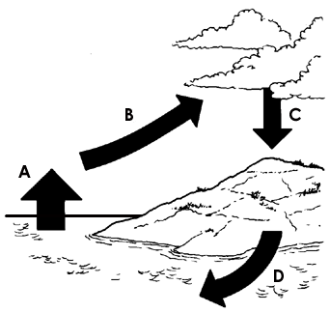This is a diagram of the water cycle. Explain what is happening to the water at A, B, C and D.

(4 Marks)

* 1. Evaporating
  2. Rising into sky/forming clouds
  3. Condensing/condensation
  4. Flowing into the sea/run off

1. 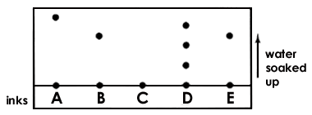The diagram shows the results of a chromatography experiment. Fine inks were compared: A, B, C, D and E. (3Marks)
2. Which ink is a mixture of different colours? D
3. Which two inks are the same? B & E
4. Which ink is not soluble in the solvent? C
5. Four substances called A, B, C and D were shaken with water. This is what happened

(4 Marks)

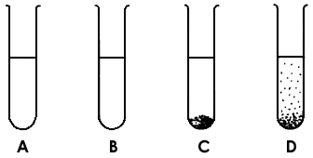

The substances were then shaken with alcohol. This is what happened.

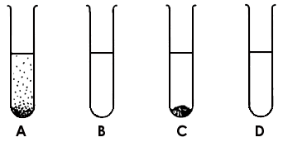

Complete this table.

|  |  |  |
| --- | --- | --- |
| Substance | Is it soluble in water? | Is it soluble in alcohol? |
| A | yes | no |
| B | yes | yes |
| C | no | no |
| D | no | yes |